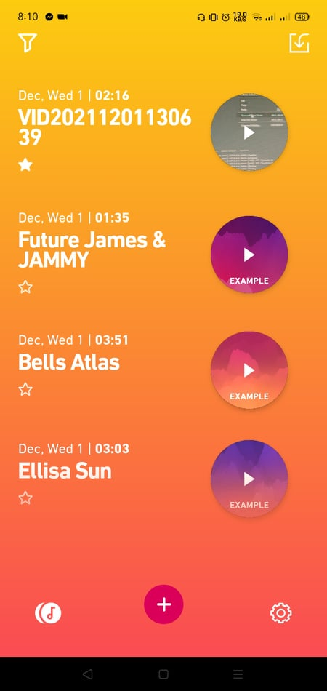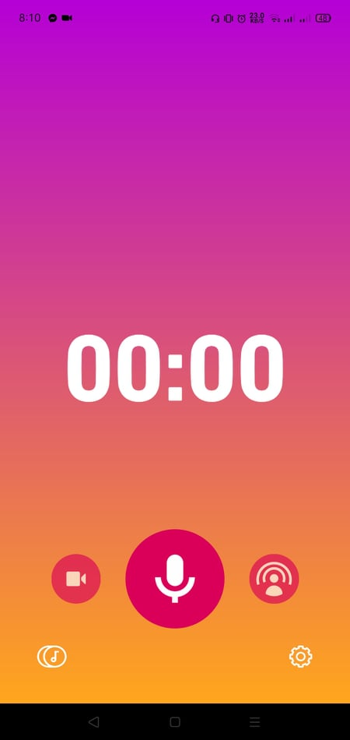

**Dolby on**

* **Easy to use and user friendly**
* **You can add and edit the audio of your video**
* **You can edit and import**
* **You can record video and audio**

**User Interface**

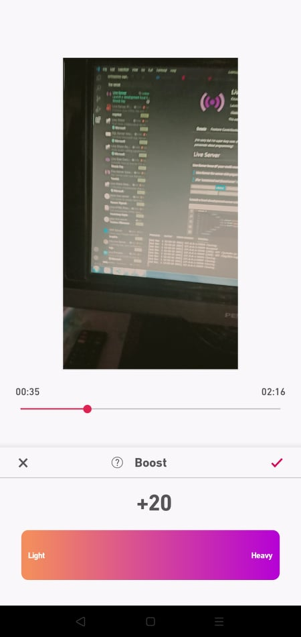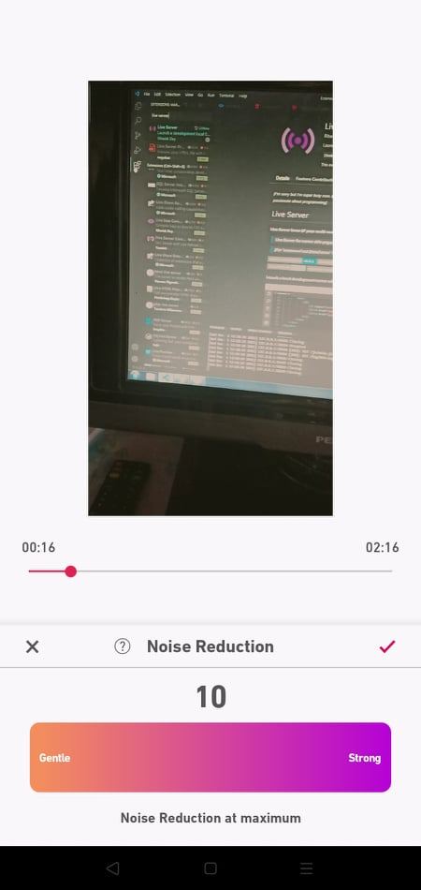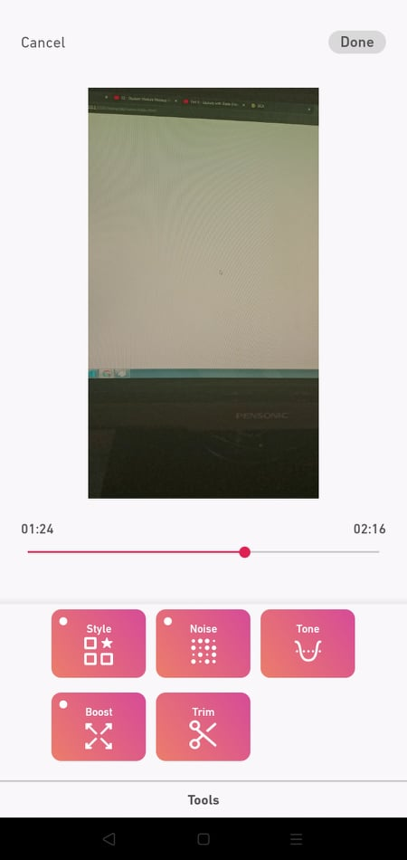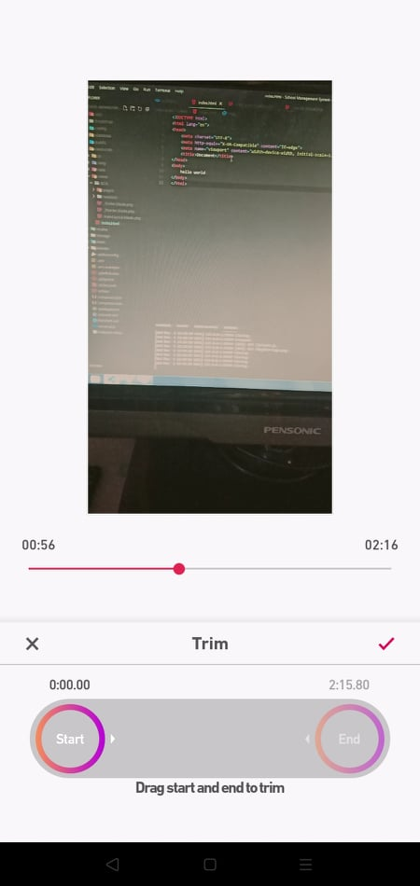

**What I like about this app is I can lower the noise of my audio/video and I can boost or add more volume in it and the app I user friendly for me.**

* **You can edit the noise of audio or video**
* **You can boost the sound**
* **You can trim the audio**
* **You can change the tone of audio**

**Features**

**Dolby on**